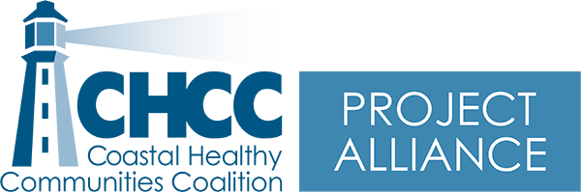 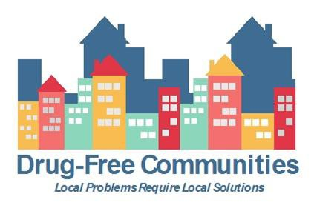 

# Minutes – Project Alliance Coalition Meeting www.chccme.org

Wednesday, December 15, 2021 9-11am via Zoom

**Present: Morgan Bates, Cheri Sullivan, Tricia Cote, Robert MacKenzie, Ashley Duffee, Christina Schechtman, Maxine Darling, Eriko Farnsworth, Jack Clements, Abigail Smallwood, Alyssa Pelchat**

**Purpose: Talk about community involvement and learn how to play/use Kahoot!**

|  |  |  |  |
| --- | --- | --- | --- |
|  | **Item** | **Details** | **Next Steps** |
| **1** | Welcome and introductions |  | * N/A |
| **2** | Member Input Survey Result discussion | * Members are looking for more opportunities to get involved in community activities * Members are looking for training opportunities specific to their respective sectors, staying motivated through the pandemic, and how to maximize social media and information dissemination | Keep an eye on our website for offered trainings and if there is anything else you are passionate about please email Morgan (mbates3@une.edu) |
| **3** | Kahoot! | * Learned how to use and play Kahoot! This is super easy to use with youth and adults alike, especially virtually as it can get everyone participating   (did you know a blob of toothpaste is called a nurdle)  <https://kahoot.com/> |  |
| **4** | Winterfest | * Biddeford is hosting Winterfest this year at the end of January. As a coalition, we would love to do something targeted towards youth. We will be forming a committee to discuss and plan this- if you want to be on that committee please email Morgan |  |
| **5** | Coalition Updates | * Alyssa from OPTIONS: working in York County to prevent substance use and overdoses. For more information contact Alyssa. They are looking for a full-time liaison for York County! * Saco PD: seeing upticks in mental health calls and seeing more drunk/impaired driving * RBS training will start to be offered in the new year. If you know of any restaurants that want to be involved please contact Morgan and we will set up a training with their staff * Chief MacKenzie: getting ready with Rotary for the RSU 21 holiday party to support youth in need with coats, hats, mittens, clothes, and school supplies. |  |

**Next Meeting: January 19, 2022 9-11am**

**Location: TBA – in person**