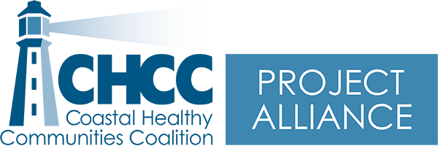 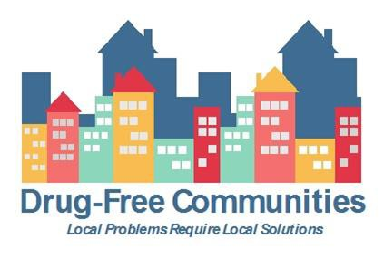 

# Minutes – Project Alliance Coalition Meeting www.chccme.org

Wednesday, November 17, 2021, 2021, 9-11am Hybrid Meeting

**Present: Morgan Bates, Cheri Sullivan, Tricia Cote, Robert MacKenzie, Ashley Duffee, Christina Schechtman, Maxine Darling, Maegan Lambert-Irish**

**Purpose: Review success from Year 6 and go over Year 7 workplan/gather ideas about what to offer**

|  |  |  |  |
| --- | --- | --- | --- |
|  | **Item** | **Details** | **Next Steps** |
| **1** | Welcome and introductions | * Introduction of Maxine Darling, the new York Youth Coordinator | * N/A |
| **2** | SADD | * The coalition looking for people to join our SADD chapter. It gives youth a great sense of leadership, belonging, and it’s a fun group to be in. * Christina shared with the coalition: There are contests going on for High School students including: * Filming a PSA idea on how to stop youth from driving high. There are prizes that go up to $25,000 and for the winning video, an Emmy award winning director helps bring you idea to life * Showing of “I Did What” showing the dangers of underage drinking with a discussion guide to help talk to youth afterwards. * National ugly sweater contest coming up where youth get to connect with others from all over the United States and can enter to win prizes * With the coalition SADD chapter we can bring different activities to school during prom and graduation season (wrecked car in the parking lot with announcements about drunk/impaired driving, drunk driving simulation) | If you would like any of the links to learn more or for the movie, please email Morgan (mbates3@une.edu) |
| **3** | What the coalition can offer to youth | * Sticker shock * Prime for Life * Photovoice * Teacher training (can be about anything that teachers would like more information on) * Change journals (interactive guided journaling <https://www.changecompanies.net/products/>) | Let us know if you want to do something or partner with your youth!! |
| **4** | Coalition updates | * Robert with the Kennebunk Task Force: They have identified 5 major substance use problems and the steering committee has been broke up into smaller groups to address these problems |  |

**Next Meeting: December 16th, 2021 9am-11am (should really only last an hour though)**

**Location: Zoom**